Simple GenAI Chat App using LangChain
Features
- Chat-based AI interaction
- Prompt templating
- Environment-based API key management
- Clean and modular structure
- Uses latest LangChain (langchain-core, langchain-openai)
Tech Stack
- Python
- LangChain
- OpenAI API
- python-dotenv

Project Structure
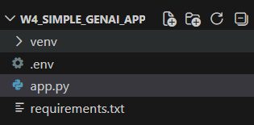
Setup Instructions:
- Create virtual environment
- Install dependencies
- Add API Key
- Run the app

Code used within app.py
from langchain_openai import ChatOpenAI
from langchain_core.prompts import PromptTemplate
import os
from dotenv import load_dotenv

load_dotenv()

llm = ChatOpenAI(
openai_api_key=os.getenv("OPENAI_API_KEY"),
temperature=0.7
)

prompt = PromptTemplate.from_template(
"You are a helpful AI assistant.\nUser says: {user_input}\nYour response:"
)

if __name__ == "__main__":
user_input = input("Ask me anything: ")
chain = prompt | llm
response = chain.invoke({"user_input": user_input})
print("AI says:", response.content)

Requirements.txt file
langchain
langchain-core
langchain-openai
python-dotenv
openai

.env example
OPENAI_API_KEY=your_api_key_here

